Composite Building Material
Report for: Capvond Plastics Ltd.
Draft v1.0

12th March 2018

Contributors: Mr Kristof Starost
Ms Ruissein Mahon
Dr. James Njuguna

Contact Details:
Kristof Starost
Lecturer (Mechanical Engineering)
School of Engineering, Robert Gordon University
Sir Ian Wood Buidling, Garthdee Road, Aberdeen, AB10 7JG, United Kingdom
T: +44 (0)1224 263176, E: k.starost2@rgu.ac.uk, W: www.rgu.ac.uk

Table of Contents
Project Overview (from IV application) 1
Test Matrix 1
Test Procedure 3
Results 5
Concrete Compressive Strength Testing 5
Plastic Composite Compressive Strength Testing 6
Uniaxial Compressive Testing: Maximum Load Comparison 7
Uniaxial Compression Testing: Compressive Stress Comparison 9
Concrete Flexural Strength Testing 12
Plastic Composite Flexural Strength Testing 13
Flexural Strength Testing: Maximum Load Comparison 14
Flexural Strength Testing: Flexure Stress Comparison 16
Summary 19
Appendix 1: UCS Testing 20
Concrete Samples at Room Temperature 20
Concrete Samples at -20 ºC 21
Concrete Samples at 50 ºC 22
Concrete Samples Wet at Room Temperature 23
Plastic Samples at Room Temperature 24
Plastic Samples at -20 ºC 25
Plastic Samples at 50 ºC 26
Plastic Samples Wet at Room Temperature 27
Appendix 2: Flexural Testing 28
Concrete Samples at Room Temperature 28
Concrete Samples at -20ºC 29
Concrete Samples at 50ºC 30
Concrete Samples Wet at Room Temperature 31
Plastic Samples at Room Temperature 32
Plastic Samples at -20ºC 33
Plastic Samples at 50ºC 34
Plastic Samples Wet at Room Temperature 35

List of Tables
Table 1: Material test procedures matrix (Note: 1 sample as a contingency was added to the 5 samples required to be tested as per the test standards) 2
Table 2: Maximum load of concrete samples at different conditions 7
Table 3: Mean and standard deviation values for all concrete samples under different conditions 7
Table 4: Maximum load of plastic samples on different conditions 7
Table 5: Mean and standard deviation values for all plastic samples under different conditions 7
Table 6: Compressive stress of concrete samples on different conditions 9
Table 7: Compressive stress of plastic samples on different conditions 9
Table 8: Mean and standard deviation values for compressive stress of all concrete samples under different conditions 9
Table 9: Mean and standard deviation values for compressive stress of all plastic samples under different conditions 9
Table 10: Concrete and plastic composite sample weight before and after exposure to water 11
Table 11: Concrete and plastic composite sample performance comparison 11
Table 12: Flexural tests maximum load of concrete samples on different conditions 14
Table 13: Mean and standard deviation values for maximum load of all concrete samples under different conditions 14
Table 14: Flexural tests maximum load of plastic samples on different conditions 14
Table 15: Mean and standard deviation values for maximum load of all concrete samples under different conditions 14
Table 16: Flexural tests maximum flexure stress of concrete samples on different conditions 16
Table 17: Mean and standard deviation values for flexure stress of concrete under different conditions 16
Table 18: Flexural tests maximum flexure stress of plastic samples on different conditions 16
Table 19: Mean and standard deviation values for flexure stress of all plastic samples under different conditions 16
Table 20: Concrete and plastic composite flexural sample weight before and after exposure to water 18
Table 21: Concrete and Plastic composite flexural performance comparison 19

List of Figures
Figure 1: Schematic of typical facture patterns 4
Figure 2: Concrete samples at room temperature 5
Figure 3: Concrete samples at -20 ºC 5
Figure 4: Concrete samples at 50 ºC 5
Figure 5: Concrete samples wet 5
Figure 6: Plastic samples at room temperature 6
Figure 7: Plastic samples at -20 ºC 6
Figure 8: Plastic samples at 50 ºC 6
Figure 9: Plastic samples we 6
Figure 10: Bar graph of mean maximum load of both concrete and plastic samples 8
Figure 11: Line graph of average maximum load of both concrete and plastic samples 8
Figure 12: Line graph of average compressive stress of both concrete and plastic samples 10
Figure 13: Line graph of average compressive stress of both concrete and plastic samples 10
Figure 14: Flexural concrete samples at room temperature 12
Figure 15: Flexural concrete samples at -20 ºC 12
Figure 16: Flexural concrete samples at 50 ºC 12
Figure 17: Flexural concrete samples wet 12
Figure 18: Flexural plastic samples at room temperature 13
Figure 19: Flexural plastic samples at -20 ºC 13
Figure 20: Flexural plastic samples at 50 ºC 13
Figure 21: Flexural plastic samples wet 13
Figure 22: Bar graph of average maximum load of flexural tests of both concrete and plastic samples 15
Figure 23: Line graph of average maximum load of flexural tests of both concrete and plastic samples 15
Figure 24: Bar graph of flexural tests average flexure stress of both concrete and plastic samples 17
Figure 25: Line graph of flexural tests average flexure stress of both concrete and plastic samples 17

Project Overview (from IV application)
Capvond Plastics have been developing a composite to replace and replicate cast concrete and traditional stone. The composite is an amalgam of dried “fly ash”, cenospheres, 6 or 9mm glass fibre strands bound together with a polyester resin. The composite will replace and replicate cast concrete and traditional stone for use within the construction industry.
Thus far, the composite has been used in the production of mullions, door surrounds and coping stones, and testing has been carried out on sills and architectural features, all traditionally cast in concrete or carved from stone. The future development of building products made with this composite will help to improve health & safety on building sites due to the substantially reduced weight of the new products manufactured in comparison to the weight of traditional products of comparable sizes. It is hoped that not only will the new composite offer improved durability over traditional products available, but the thermal and water resistance of the new composite will add further benefit to the overall building structure in comparison to what is currently available. Alongside the benefits above, products made with the new composite will also be quicker and easier to fit.
Through this project, the composites will be tested to understand the capabilities in comparison to traditional products. New formulations of the composite are to be tested for various material properties under different conditions allowing Capvond to supply with confidence, a product fit for purpose. The material testing of various properties under different environmental conditions will allow Capvond Plastics to supply with confidence, a product fit for purpose. The composite developed by Capvond Plastics Ltd will allow them to replace traditional stone building materials with a lighter and more durable product, improving health and safety on site and lowering carbon requirements for transport.

Test Matrix
The composites developed by Capvond Plastics Ltd were tested for material performance at RGU. Relevant to the construction industry, the compressive and flexural properties were identified to be the most influential properties required. The materials would undergo varying environmental conditions depending on the location and time of year throughout its lifecycle. In contemplation of the construction industry, concrete was chosen as a reference sample to compare the composite material.
A material testing regime was carried out at RGU following the below setup in
Table 1: Material test procedures matrix (Note: 1 sample as a contingency was added to the 5 samples required to be tested as per the test standards)
 | Sample size [mm] | Material Test and number of samples |  |  |  |  |  |  |  | Total
 | Sample size [mm] | Flexural: ASTM C293 |  |  |  | Compressive: ASTM C109 |  |  |  | Total
 | Sample size [mm] | C1 | C2 | C3 | C4 | C1 | C2 | C3 | C4 | Total
Concrete reference | 150x50x50 | 6 | 6 | 6 | 6 |  |  |  |  | 24
Concrete reference | 50x50x50 |  |  |  |  | 6 | 6 | 6 | 6 | 24
Composite Specimen | 150x50x50 | 6 | 6 | 6 | 6 |  |  |  |  | 24
Composite Specimen | 50x50x50 |  |  |  |  | 6 | 6 | 6 | 6 | 24
 |  |  |  |  |  |  |  |  |  | 96

AS shown in Table 1, four environmental conditions were chosen to evaluate the performance under different conditions as follows:
- C1 = Room temperature and no environmental exposure
- C2 = -20ºC and no environmental exposure
- C3 = -50ºC and no environmental exposure
- C4 = Water exposure
More details of the preparation and material soaking are provided in the following section.

Test Procedure
All experiments were performed using a Universal testing machine (Instron 3382) at Robert Gordon University’s Materials Mechanical Testing Laboratory. Tests were conducted according to ASTM C293 and ASTM C109 standards at a crosshead speed of 2mm/min for a 3-point flexural and compression strength respectively. For each test the following steps were carried out:
- Prepare concrete and plastic samples under varying conditions for compression and flexural testing (given below).
- Verify that the samples do not have any significant defects that may affect the quality of the test results.
- Record the sample identifier.
- Prepare the testing machine.
- Install bearing blocks or 3 point bend test fixtures as necessary to successfully complete compression testing of the samples.
- Turn on the testing machine and allow the electronic and hydraulic systems to equalize for a minimum of 15 minutes. Equalization of the electrical and hydraulic systems is necessary to ensure stable readings and repeatable results.
- Test each sample as soon as practicable after removal from its previous state of conditioning.
- Wipe the concrete sample as necessary to remove any surface moisture.
- For compression: wipe clean the bearing faces of the upper and lower bearing blocks and place the sample on the lower bearing block. Using the concentric circles on the bearing block and lower platen as points of reference, carefully align the axis of the sample with the upper spherical seat.
For Flexural: place sample on lower two rollers and measure distance overhanging on both ends to assure positioning of sample.
- Zero the force readout of the testing machine and prepare the machine for testing.
- Apply load continuously at a rate of movement corresponding to a strain rate on the sample.
- Continue to apply load until the sample fails and displays a well-defined fracture pattern.
- Record the maximum load carried by the sample during the test and note the type of fracture pattern (refer to Figure 1). The fracture pattern is documented with a camera and available in Appendix A.
- For compression: calculate the compressive strength of the samples using:

$$σ_{C}=\frac{F}{A}$$

Where σ_{c} = uniaxial compressive stress, F = load applied at fracture point, and A = cross-sectional area

For Flexural: calculate the flexural strength of materials using:

$$σ_{F}=\frac{3FL}{2bd^{2}}$$

Where σ_{F} = flexural stress, F = load applied at fracture point, L = length of support span, b = width, and d= thickness
Continued…
- Record the strength of each sample.
- Clean the test machine after testing.
- Clean all dust and debris from the test machine.
- Power off the test machine.

The specimens were prepared for the relevant test condition prior to testing:
- C1: kept at room temperature for 24 hours before testing.
- C2: soaked in freezer at – 20ºC for 24 hours before testing.
- C3: soaked in oven at 50ºC for 24 hours before testing.
- C4: suspended in tap water for 1 week before testing.
For C4, the materials were weighed before and after suspension in the water to evaluate the water absorption.
Figure 1 displays some typical fracture patterns that can be used when evaluating the photographs of the fractures displayed in Appendix 1.
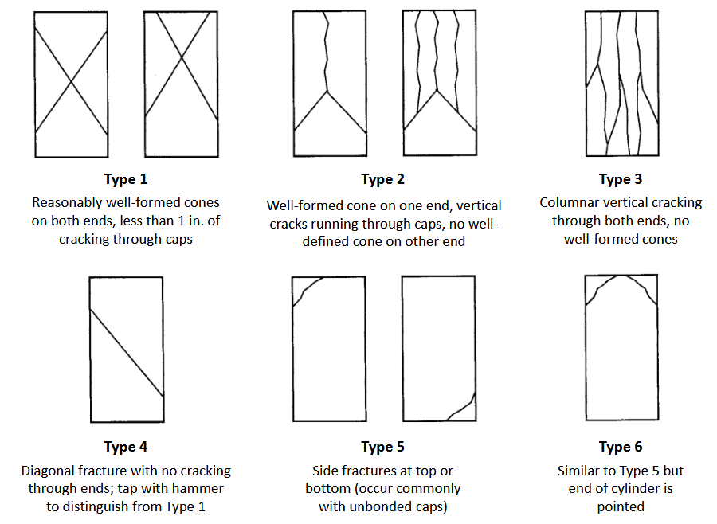
Figure 1: Schematic of typical facture patterns

Results

Concrete Compressive Strength Testing
This section covers the determination of the uniaxial compressive strength of the materials. The results display the 5 test samples required as per the ASTMC109 test standard.
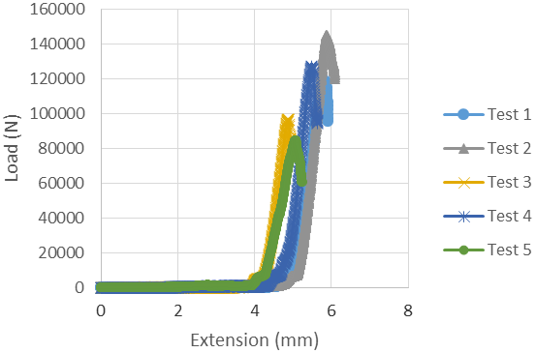 | 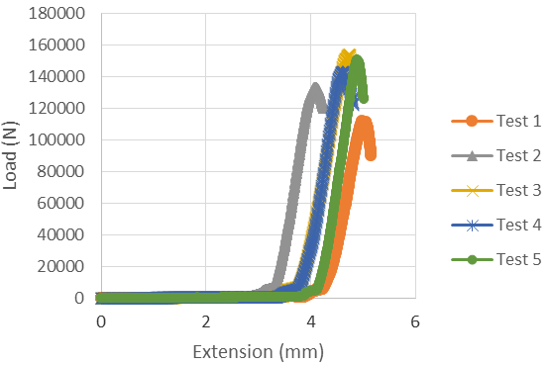
Figure 2: Concrete samples at room temperature | Figure 3: Concrete samples at -20 ºC
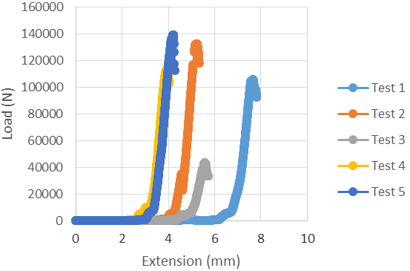 | 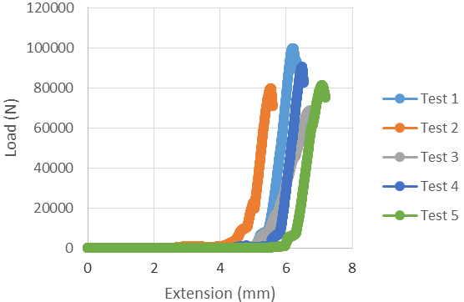
Figure 4: Concrete samples at 50 ºC | Figure 5: Concrete samples wet
NB: Axis are different for each condition.
Due to slight differences in material sizes, the initial stage in pre-loading can be seen to vary for the samples. The extension prior to the load increase should therefore not be considered. The linear region following Hooke’s law for the concrete, Young’s Modulus for Compression, can be seen to be parallel between sample tests during the elastic deformation of the materials. The ultimate yield points, uniaxial compressive strength, can be seen to differ between samples (most notably for the concrete samples at 50ºC). Further analysis and provided in the numerical data in following section. The tests were stopped after the yield point and fracture.

Plastic Composite Compressive Strength Testing
Material compressive performance was also plotted for the plastic composite samples.
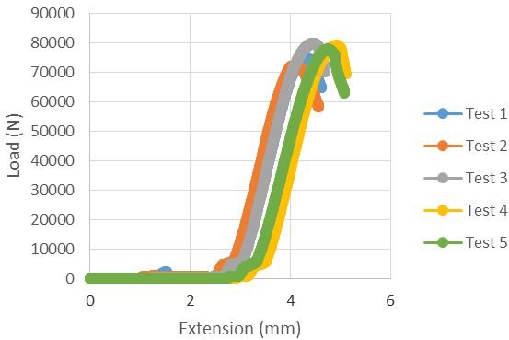 | 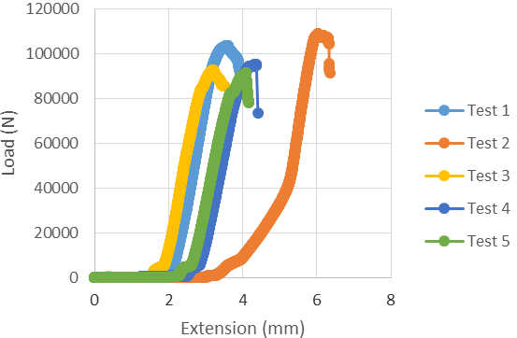
Figure 6: Plastic samples at room temperature | Figure 7: Plastic samples at -20 ºC
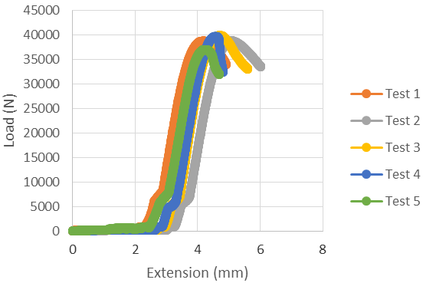 | 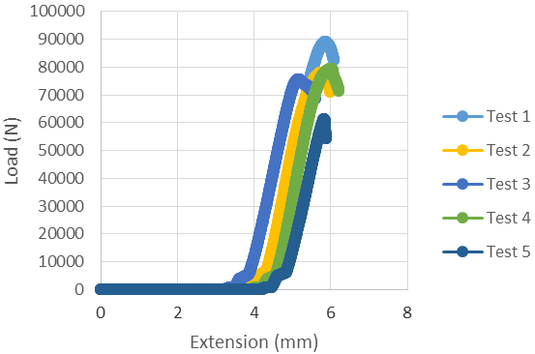
Figure 8: Plastic samples at 50 ºC | Figure 9: Plastic samples we
From the raw data plots of the plastic and concrete under compression, the plastic sample can be seen to have a slight decrease in compression performance. However, the plastic demonstrated a smaller deviation between samples and therefore more consistent material compressive strength. This is more evident in the numerical values of the data.

Uniaxial Compressive Testing: Maximum Load Comparison
The values gathered for the maximum load in the compression testing on the two sets of samples are compared in this section. For each sample, the maximum load observed prior to failure is displayed in Table 2 and Table 4. The mean and standard deviations were computed for the statistical representation of the data in Figure 10 and 11.
Table 2: Maximum load of concrete samples at different conditions
Concrete | Sample 1 | Sample 2 | Sample 3 | Sample 4 | Sample 5
RT | 118928.9 N | 145087.2 N | 96939.3 N | 127376.2 N | 84717.8 N
-20 ºC | 112372.9 N | 133310.9 N | 154265.4 N | 143124.3 N | 150926.2 N
50 ºC | 105764.0 N | 132819.0 N | 43495.9 N | 112974.6 N | 139242.4 N
Wet | 100124.1 N | 79911.4 N | 68820.1 N | 90595.4 N | 81474.5 N
Table 3: Mean and standard deviation values for all concrete samples under different conditions
Concrete | Mean | Std. Dev.
RT | 114609.8 N | 24063.9 N
-20 ºC | 138799.9 N | 16833.3 N
50 ºC | 106859.2 N | 38000.3 N
Wet | 84185.1 N | 11798.7 N
Table 4: Maximum load of plastic samples on different conditions
Plastic | Sample 1 | Sample 2 | Sample 3 | Sample 4 | Sample 5
RT | 74948.5 N | 72491.2 N | 79954.9 N | 79191.5 N | 77929.0 N
-20 ºC | 103722.1 N | 109130.9 N | 92697.3 N | 95262.2 N | 91552.4 N
50 ºC | 38804.6 N | 38848.6 N | 39909.4 N | 39740.6 N | 37047.0 N
Wet | 89112.4 N | 78184.8 N | 75620.0 N | 79516.5 N | 61507.7 N
Table 5: Mean and standard deviation values for all plastic samples under different conditions
Plastic | Mean | Std. Dev.
RT | 76903.0 N | 3118.0 N
-20 ºC | 98473.0 N | 6822.1 N
50 ºC | 38610.2 N | 976.7 N
Wet | 76788.3 N | 8901.0 N

The values in Tables 2-5 are represented in Figure 10 and Figure 11. The two materials observed similar trends of increased performance for -20ºC and decreased performance for 50ºC. The exposure within water observed almost no effect on the plastic composite compressive performance. The average ultimate load demonstrated no shift and a consistent set of data between samples, whereas the concrete demonstrated a significant decrease in performance in relation to the performance at room temperature.

Figure 10: Bar graph of mean maximum load of both concrete and plastic samples

Figure 11: Line graph of average maximum load of both concrete and plastic samples
Furthermore, the standard deviation between samples can be seen to be more consistent with the plastic composite materials. The high standard deviation between samples observed in the concrete samples demonstrates a high unpredictability and non-uniformity in the material. The consistency of the plastic composites demonstrates a reliable and predictable behaviour.

Uniaxial Compression Testing: Compressive Stress Comparison
As discussed in the test procedure section, the ultimate load under compression can be utilised to calculate the compressive strength of the material. Using this value as the yield point of force applied and the cross-sectional area, the compressive stress values were calculated:
Table 6: Compressive stress of concrete samples on different conditions
Concrete | Sample 1 | Sample 2 | Sample 3 | Sample 4 | Sample 5
RT | 44.6 MPa | 58.0 MPa | 38.8 MPa | 51.0 MPa | 33.9 MPa
-20 ºC | 45.0 MPa | 53.3 MPa | 61.7 MPa | 57.3 MPa | 60.4 MPa
50 ºC | 42.3 MPa | 53.1 MPa | 17.4 MPa | 45.2 MPa | 55.7 MPa
Wet | 40.0 MPa | 32.0 MPa | 27.5 MPa | 36.2 MPa | 32.6 MPa
Table 7: Compressive stress of plastic samples on different conditions
Plastic | Sample 1 | Sample 2 | Sample 3 | Sample 4 | Sample 5
RT | 30.0 MPa | 29.0 MPa | 32.0 MPa | 31.7 MPa | 31.2 MPa
-20 ºC | 41.5 MPa | 43.7 MPa | 37.1 MPa | 38.1 MPa | 36.6 MPa
50 ºC | 15.5 MPa | 15.5 MPa | 16.0 MPa | 15.9 MPa | 14.8 MPa
Wet | 36.7 MPa | 31.3 MPa | 30.3 MPa | 31.8 MPa | 24.6 MPa
Table 8: Mean and standard deviation values for compressive stress of all concrete samples under different conditions
Concrete | Mean | Std. Dev.
RT | 45.3 MPa | 9.6 MPa
-20 ºC | 55.5 MPa | 6.7 MPa
50 ºC | 42.7 MPa | 15.2 MPa
Wet | 33.7 MPa | 4.7 MPa
Table 9: Mean and standard deviation values for compressive stress of all plastic samples under different conditions
Plastic | Mean | Std. Dev.
RT | 30.8 MPa | 1.3 MPa
-20 ºC | 39.4 MPa | 2.8 MPa
50 ºC | 15.5 MPa | 0.4 MPa
Wet | 30.9 MPa | 3.9 MPa

Figure 12: Line graph of average compressive stress of both concrete and plastic samples

Figure 13: Line graph of average compressive stress of both concrete and plastic samples
Since the stress values are calculated from the load and a uniform cross-sectional area, the plots show identical trends in material behaviour as the maximum load data. The compressive strength is one of the most important engineering properties of concrete and is therefore presented.
Table 10: Concrete and plastic composite sample weight before and after exposure to water
Type | Sample | Weight Before (g) | Weight after (g) | Change (g) | % change
Concrete compression sample | 1 | 305.8 | 309.3 | 3.5 | 1.14
Concrete compression sample | 2 | 306.8 | 310.3 | 3.5 | 1.14
Concrete compression sample | 3 | 298.1 | 301.7 | 3.6 | 1.21
Concrete compression sample | 4 | 301.0 | 305.6 | 4.6 | 1.53
Concrete compression sample | 5 | 292.9 | 295.8 | 2.9 | 0.99
Plastic composite compression sample | 1 | 109.8 | 109.7 | -0.1 | -0.09
Plastic composite compression sample | 2 | 112.8 | 113.0 | 0.2 | 0.18
Plastic composite compression sample | 3 | 111.0 | 111.4 | 0.4 | 0.36
Plastic composite compression sample | 4 | 112.2 | 112.5 | 0.3 | 0.27
Plastic composite compression sample | 5 | 111.9 | 112.1 | 0.2 | 0.18

From Table 10, further understanding as to the minimal change in compression performance from the plastic composites is ascertained. The average percentage weight change (and therefore water absorption) between the concrete at 1.20 % compared to 0.18% for the plastic composite, can be seen to influence the compressive properties.
The material weight shown in Table 10 also highlights the weight difference between the plastic and concrete samples. Weighing at an average of 112 grams before exposure, the weight of the plastic is only 37 % of the equivalent concrete sample (average of 301 grams). With this drastic weight reduction in consideration, the plastic material performed at an average of 68 % of the compressive stress of the concrete material at room temperature, as shown in Table 11. The exposure to water demonstrated the plastic sample to perform at 92 % of the compressive strength of the concrete. The largest reduction in performance is observed at 50ºC, with a 36% performance of the concrete.
Table 11: Concrete and plastic composite sample performance comparison
 | Plastic | Concrete | Difference (concrete – plastic) | Plastic / concrete %
RT | 30.8 MPa | 45.3 MPa | 14.5 MPa | 68 %
-20 ºC | 39.4 MPa | 55.5 MPa | 16.1 MPa | 71%
50 ºC | 15.5 MPa | 42.7 MPa | 27.2 MPa | 36 %
Wet | 30.9 MPa | 33.7 MPa | 2.8 MPa | 92 %

Concrete Flexural Strength Testing
This section covers the determination of the flexural strength of the materials. The results display the 5 test samples required as per the ASTMC293 test standard.
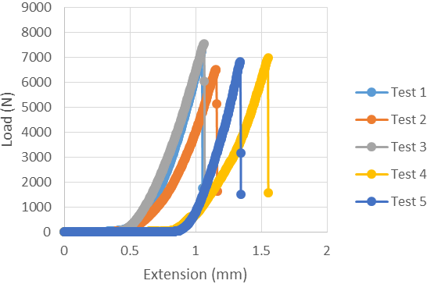 | 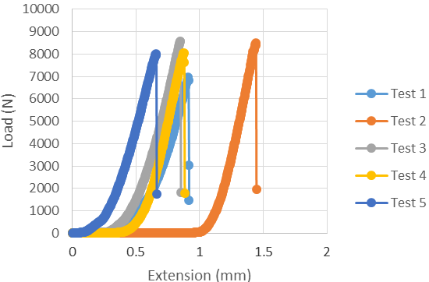
Figure 14: Flexural concrete samples at room temperature | Figure 15: Flexural concrete samples at -20 ºC
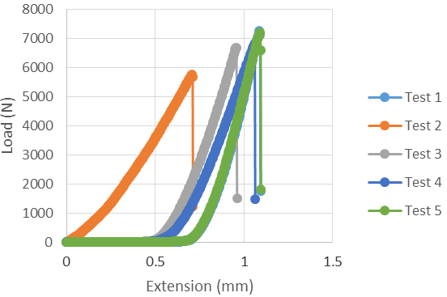 | 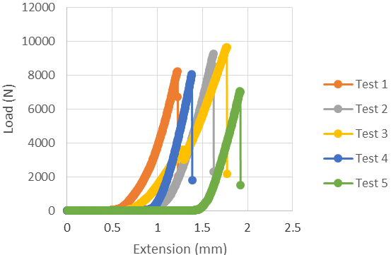
Figure 16: Flexural concrete samples at 50 ºC | Figure 17: Flexural concrete samples wet
The plots are seen to follow similar Young’s Modulus for flexural during the linear elastic region. The point of failure can be seen to be entirely brittle with the vast drops in load after the yield point. The wet exposure demonstrated the highest flexural strength and, the lowest at 50^{O}C.

Plastic Composite Flexural Strength Testing
Material flexural performance was also plotted for the plastic composite samples.
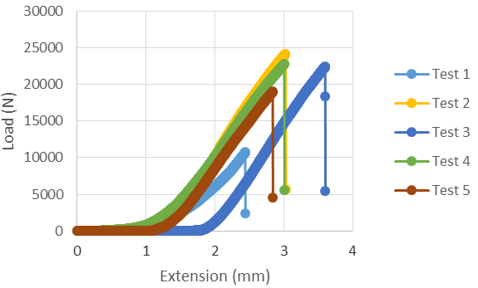 | 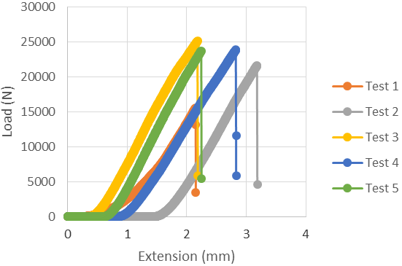
Figure 18: Flexural plastic samples at room temperature | Figure 19: Flexural plastic samples at -20 ºC
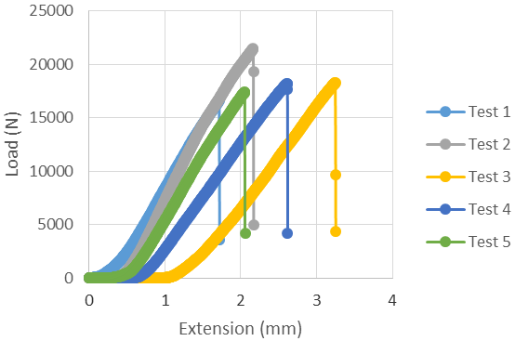 | 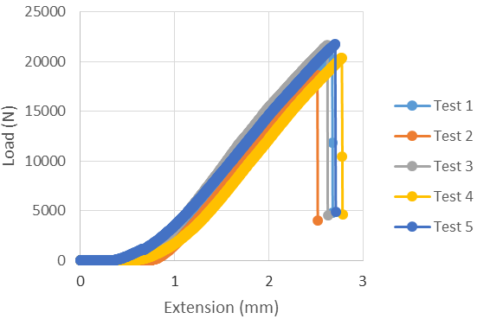
Figure 20: Flexural plastic samples at 50 ºC | Figure 21: Flexural plastic samples wet

From the raw data and comparison to the concrete samples, the plastic composite samples demonstrated a higher flexural strength. However, a more inconsistent flexural performance was observed, as highlighted in Figure 18. In contrast, the samples exposed to water (shown in Figure 21) displayed a much more repeatable set of data. A better representation of the deviation in samples is shown in the numerical values and comparison charts.

Flexural Strength Testing: Maximum Load Comparison
The values gathered for the maximum load in the flexural testing on the two sets of samples are compared in this section. For each sample, the maximum load observed prior to failure is displayed in Table 12 and Table 14. The mean and standard deviations were computed for the statistical representation of the data in Figure 22 and Figure 23.
Table 12: Flexural tests maximum load of concrete samples on different conditions
Concrete | Sample 1 | Sample 2 | Sample 3 | Sample 4 | Sample 5
RT | 7231.2 N | 6510.4 N | 7564.8 N | 6979.5 N | 6832.8 N
-20 ºC | 6594.1 N | 8496.5 N | 8571.6 N | 8039.9 N | 8017.7 N
50 ºC | 7265.3 N | 5756.9 N | 6693.3 N | 5885.8 N | 6860.1 N
Wet | 8245.8 N | 9282.0 N | 9658.1 N | 8051.6 N | 7065.6 N
Table 13: Mean and standard deviation values for maximum load of all concrete samples under different conditions
Concrete | Mean | Std. Dev.
RT | 7023.7 N | 399.3 N
-20 ºC | 7944.0 N | 796.2 N
50 ºC | 6492.3 N | 648.4 N
Wet | 8460.6 N | 1033.0 N

Table 14: Flexural tests maximum load of plastic samples on different conditions
Plastic | Sample 1 | Sample 2 | Sample 3 | Sample 4 | Sample 5
RT | 10748.1 N | 24160.5 N | 22405.5 N | 22786.3 N | 19000.1 N
-20 ºC | 15582.1 N | 21672.0 N | 25159.7 N | 23894.5 N | 23768.6 N
50 ºC | 16652.6 N | 21483.1 N | 18328.4 N | 18226.2 N | 17419.1 N
Wet | 20274.9 N | 18641.2 N | 21663.9 N | 20420.6 N | 21768.6 N
Table 15: Mean and standard deviation values for maximum load of all concrete samples under different conditions
Plastic | Mean | Std. Dev.
RT | 19820.1 N | 5415.1 N
-20 ºC | 22015.4 N | 3405.8 N
50 ºC | 18421.9 N | 1646.5 N
Wet | 20553.8 N | 1136.8 N

Figure 22: Bar graph of average maximum load of flexural tests of both concrete and plastic samples

Figure 23: Line graph of average maximum load of flexural tests of both concrete and plastic samples
The comparison of the flexural performance of the samples, demonstrates the significant improvement with the use of the plastic composite. Concrete is known to typically have higher compressive strength than tensile strengths. When undergoing a 3-point bend test, concrete can therefore, also due to any material defects causing stress concentrations, expect to have lower flexural strengths than compressive. In contrast, plastic composites have a higher flexural performance.

Flexural Strength Testing: Flexure Stress Comparison
As discussed in the test procedure section, the ultimate load under compression can be utilised to calculate the compressive strength of the material. Using this value as the yield point of force applied and the cross-sectional area, the compressive stress values were calculated:
Table 16: Flexural tests maximum flexure stress of concrete samples on different conditions
Concrete | Sample 1 | Sample 2 | Sample 3 | Sample 4 | Sample 5
RT | 13.0 MPa | 11.7 MPa | 13.6 MPa | 12.6 MPa | 12.3 MPa
-20 ºC | 11.9 MPa | 15.3 MPa | 15.4 MPa | 14.5 MPa | 14.4 MPa
50 ºC | 13.1 MPa | 10.4 MPa | 12.0 MPa | 10.6 MPa | 12.3 MPa
Wet | 14.8 MPa | 16.7 MPa | 17.4 MPa | 14.5 MPa | 12.7 MPa
Table 17: Mean and standard deviation values for flexure stress of concrete under different conditions
Concrete | Mean | Std. Dev.
RT | 12.6 MPa | 0.7 MPa
-20 ºC | 14.3 MPa | 1.4 MPa
50 ºC | 11.7 MPa | 1.2 MPa
Wet | 15.2 MPa | 1.9 MPa
Table 18: Flexural tests maximum flexure stress of plastic samples on different conditions
Plastic | Sample 1 | Sample 2 | Sample 3 | Sample 4 | Sample 5
RT | 19.3 MPa | 43.5 MPa | 40.3 MPa | 41.0 MPa | 34.2 MPa
-20 ºC | 28.0 MPa | 39.0 MPa | 45.3 MPa | 43.0 MPa | 42.8 MPa
50 ºC | 30.0 MPa | 38.7 MPa | 33.0 MPa | 32.8 MPa | 31.4 MPa
Wet | 36.5 MPa | 33.6 MPa | 39.0 MPa | 36.8 MPa | 39.2 MPa
Table 19: Mean and standard deviation values for flexure stress of all plastic samples under different conditions
Plastic | Mean | Std. Dev.
RT | 35.7 MPa | 9.7 MPa
-20 ºC | 39.6 MPa | 6.1 MPa
50 ºC | 33.2 MPa | 3.0 MPa
Wet | 37.0 MPa | 2.0 MPa

Figure 24: Bar graph of flexural tests average flexure stress of both concrete and plastic samples

Figure 25: Line graph of flexural tests average flexure stress of both concrete and plastic samples
Similar with the plots of the maximum load observed from the samples, the plastic composite samples exhibited a significant improvement in flexural performance over the concrete samples. From Figure 25, the concrete observed a more consistent flexural stress, but at much lower stress values than the plastic composites. The lower temperature of -20oC, displayed the greatest flexural strength for the plastic composite, whereas the water exposure demonstrated the highest flexural strength for the concrete samples.
Table 20: Concrete and plastic composite flexural sample weight before and after exposure to water
Type | Sample | Weight Before (g) | Weight after (g) | Change (g) | % change
Concrete flexural sample | 1 | 927.0 | 936.5 | 9.5 | 1.02
Concrete flexural sample | 2 | 914.0 | 924.0 | 10 | 1.09
Concrete flexural sample | 3 | 935.5 | 947.5 | 12 | 1.28
Concrete flexural sample | 4 | 930.0 | 938.5 | 8.5 | 0.91
Concrete flexural sample | 5 | 876.0 | 884.0 | 8 | 0.91
Plastic composite flexural sample | 1 | 340.1 | 340.6 | 0.5 | 0.15
Plastic composite flexural sample | 2 | 339.0 | 339.7 | 0.7 | 0.21
Plastic composite flexural sample | 3 | 347.6 | 348.0 | 0.4 | 0.12
Plastic composite flexural sample | 4 | 340.2 | 340.8 | 0.6 | 0.18
Plastic composite flexural sample | 5 | 343.7 | 344.3 | 0.6 | 0.17

From Table 20, further understanding as to the minimal change in flexural performance from the plastic composites is ascertained. The average percentage weight change (and therefore water absorption) between the concrete at 1.05 % compared to 0.16% for the plastic composite, can be seen to influence the flexural properties. The absorption of the water displayed an increase in flexural performance for the concrete sample.
The material weight of the flexural samples shown in Table 20 also highlights the weight difference between the plastic and concrete samples. Weighing at an average of 342 grams before water exposure, the weight of the plastic is only 37 % of the equivalent concrete sample (water weight average of 917 grams, and same percentage as compressive samples). With this drastic weight reduction in consideration, the plastic material performed at an average increase of 282 % of the flexural stress of the concrete material at room temperature, as shown in Table 21. The testing at 50ºC demonstrated the plastic sample to perform at an increase of 283 % of the flexural strength of the concrete. The least improvement was observed with the exposure to water, with a 242% increased performance of the concrete.

Table 21: Concrete and Plastic composite flexural performance comparison
 | Plastic | Concrete | Difference (plastic - concrete) | Plastic / concrete % increase
RT | 35.7 MPa | 12.6 MPa | 23.0 MPa | 282 %
-20 ºC | 39.6 MPa | 14.3 MPa | 25.3 MPa | 277%
50 ºC | 33.2 MPa | 11.7 MPa | 21.5 MPa | 284 %
Wet | 37.0 MPa | 15.2 MPa | 21.8 MPa | 243 %

Summary
The concrete samples displayed in improved compressive strength over the plastic composites. Both the plastic and concrete presented the highest compressive strength at -20ºC, but the lowest compressive strength under different conditions. The plastic performed the lowest compressive strength at 50ºC, whereas the concrete sample after water exposure. After water exposure, the plastic composite samples showed similar performance to the concrete sample under compressive loading.
The plastic composite sample demonstrated a significantly higher performance over the concrete samples in maximum load and flexural stress. The lowest performance was observed at 50ºC, and the exposure to water appeared to show an increase in flexural strength for the concrete samples. Concrete is known to typically have higher compressive strength than tensile strengths. When undergoing a 3-point bend test, concrete can therefore, also due to any material defects causing stress concentrations, expect to have lower flexural strengths than compressive. In contrast, the plastic composites presented a higher flexural performance.
At an average of only 37% of the concrete sample weight, the plastic composites exhibited up to 92% of the concrete compressive strength (after water exposure) and up to an increase of 283% of the flexural strength (tested at 50ºC).

Appendix 1: UCS Testing

Concrete Samples at Room Temperature

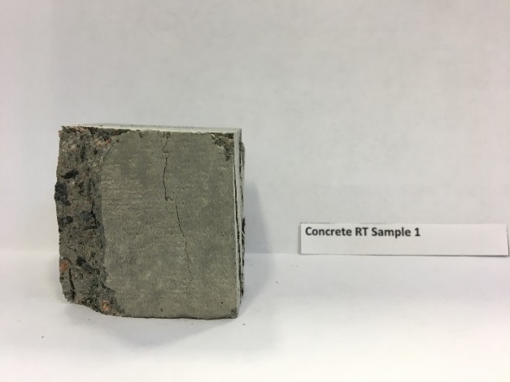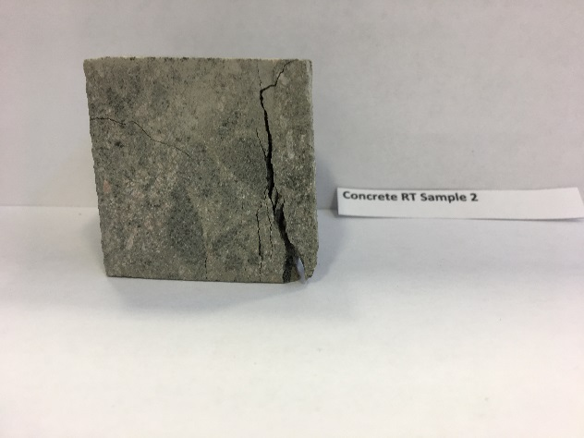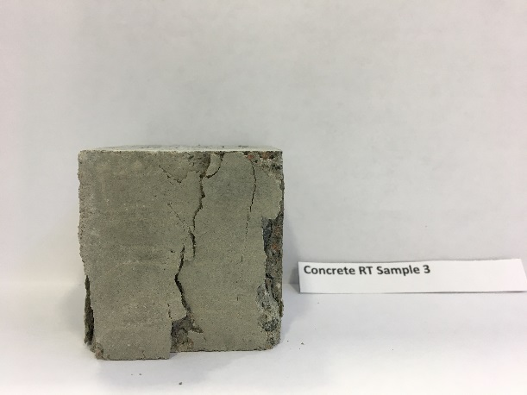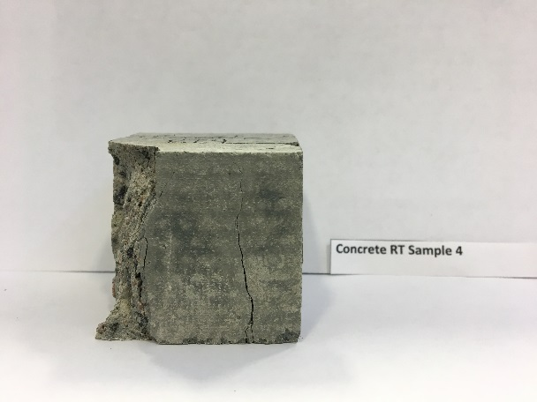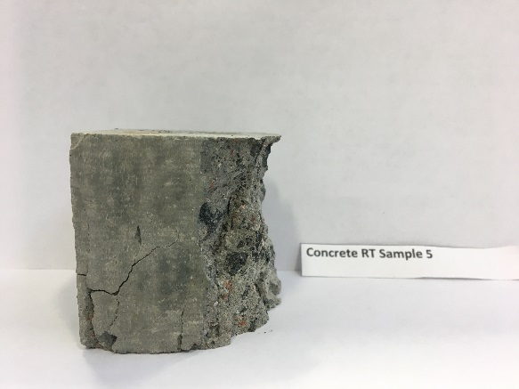

Concrete Samples at -20 ºC

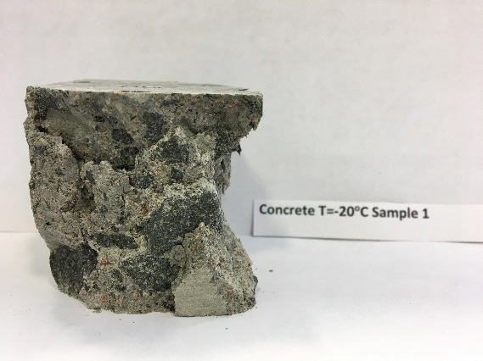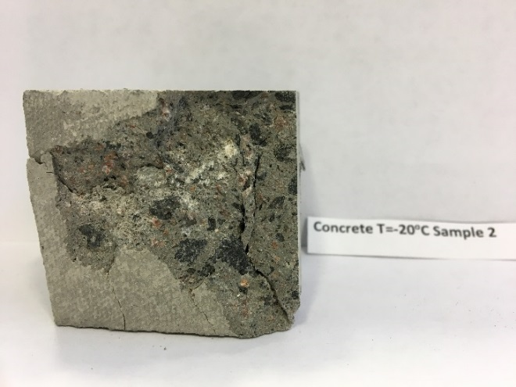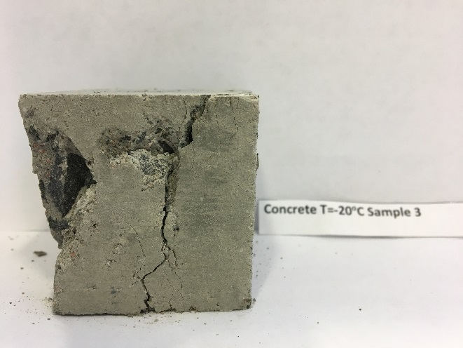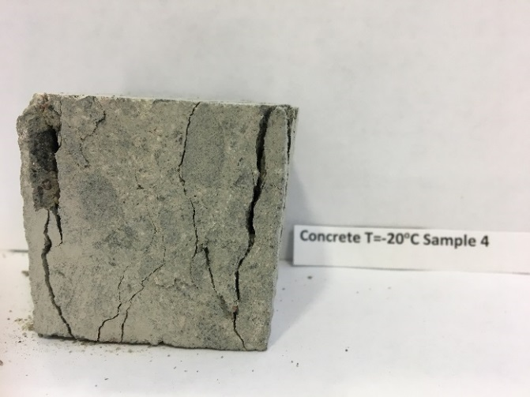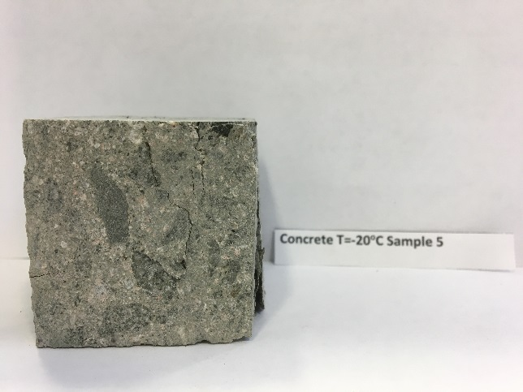

Concrete Samples at 50 ºC

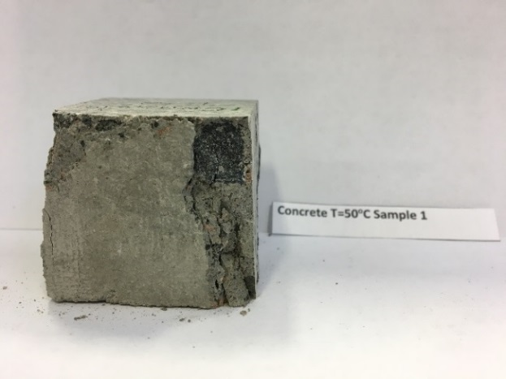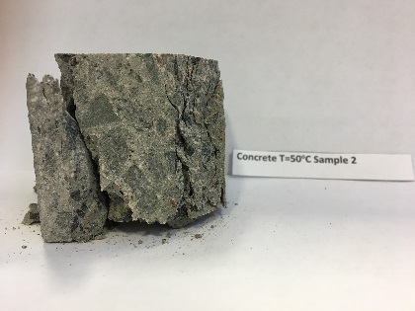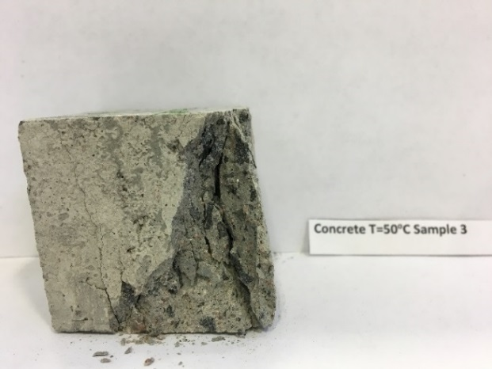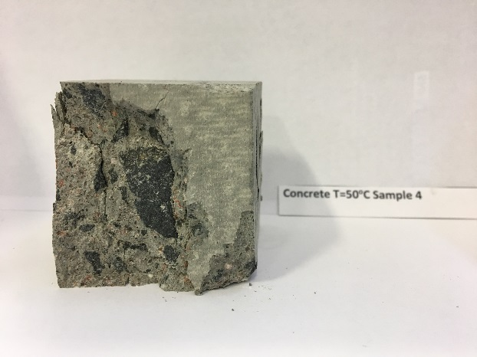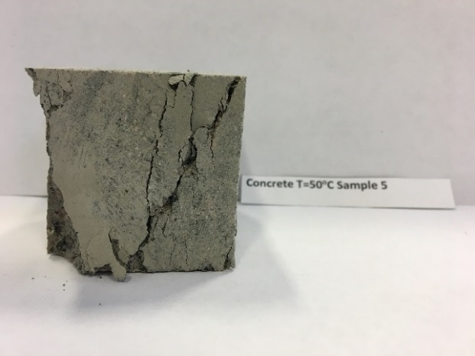

Concrete Samples Wet at Room Temperature

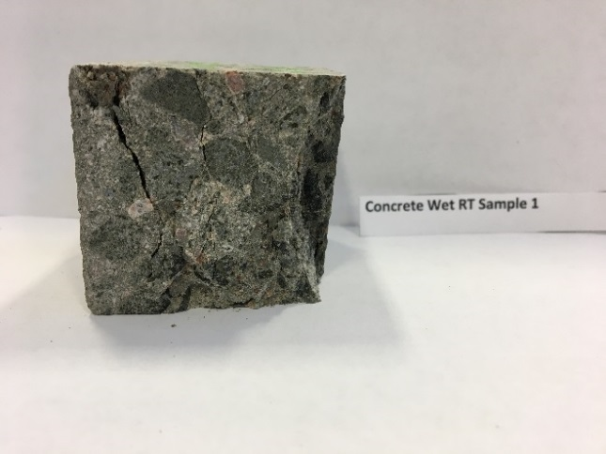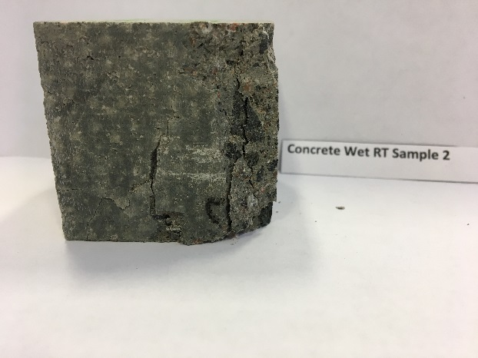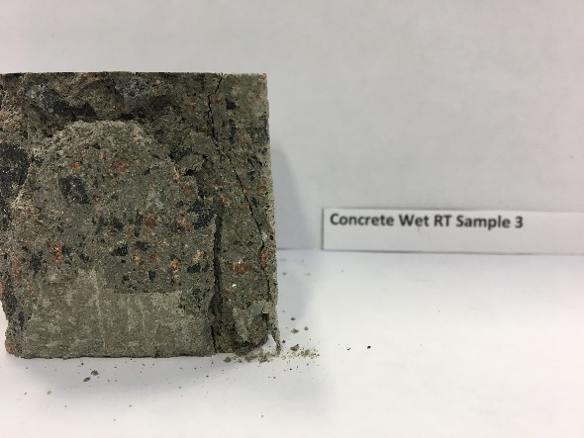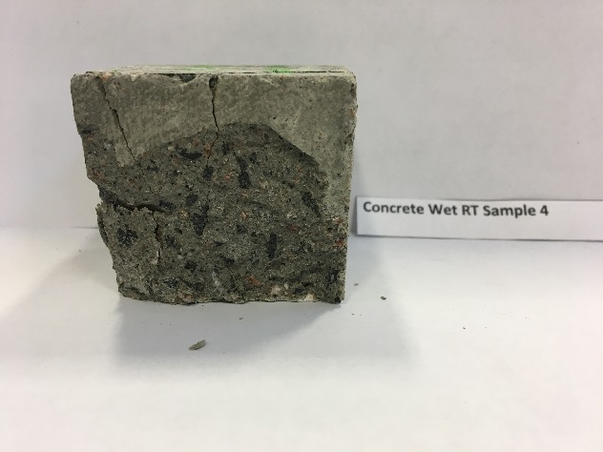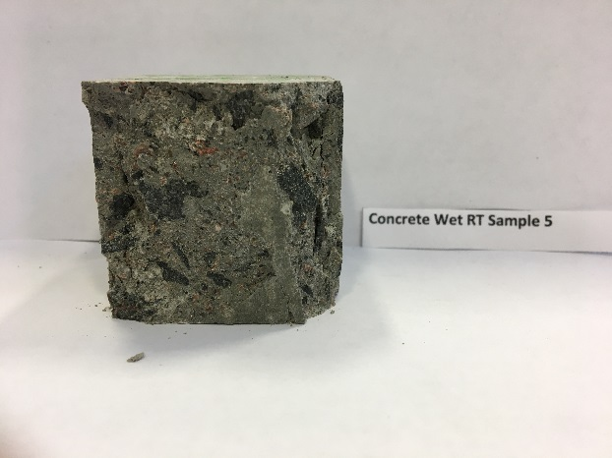

Plastic Samples at Room Temperature

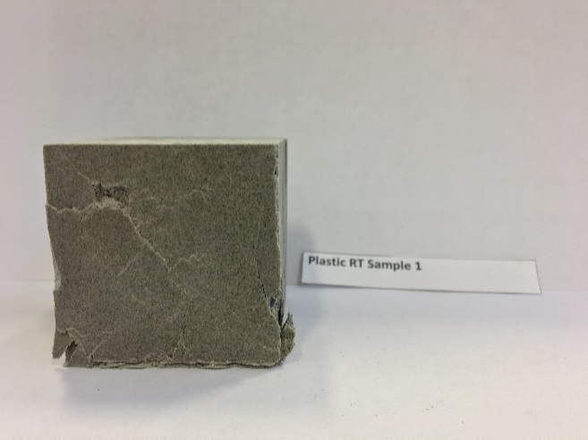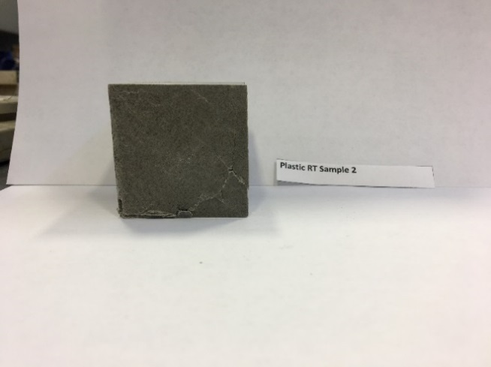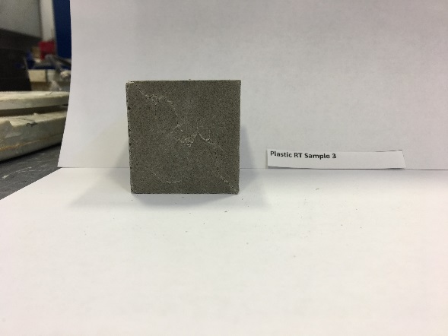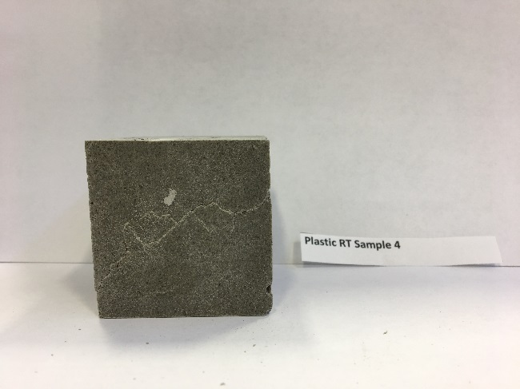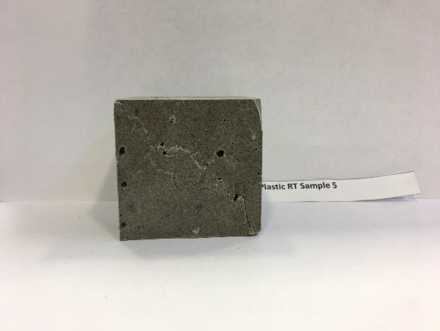

Plastic Samples at -20 ºC

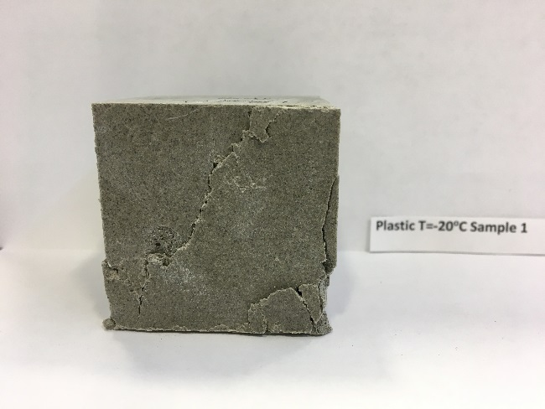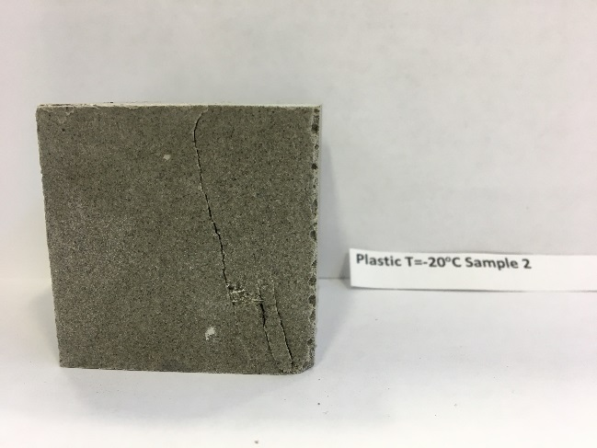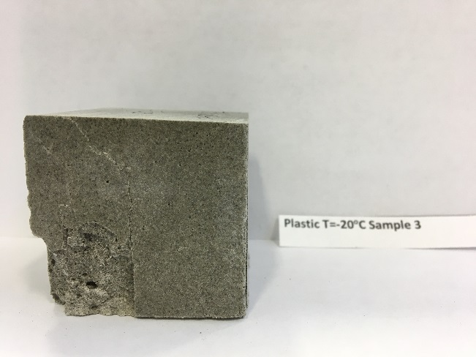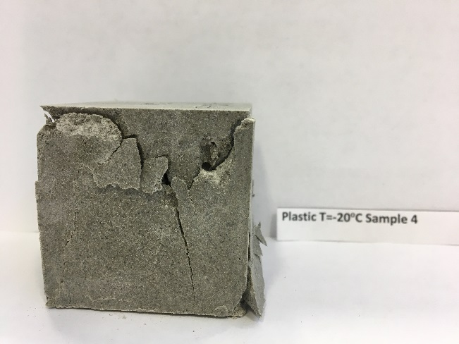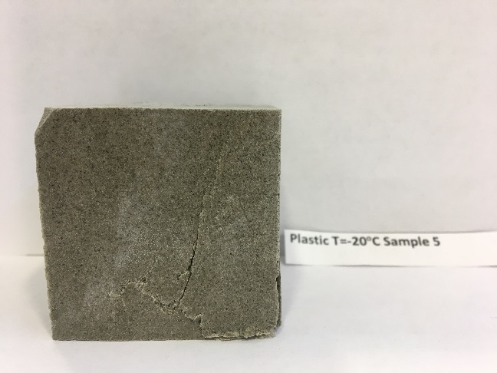

Plastic Samples at 50 ºC

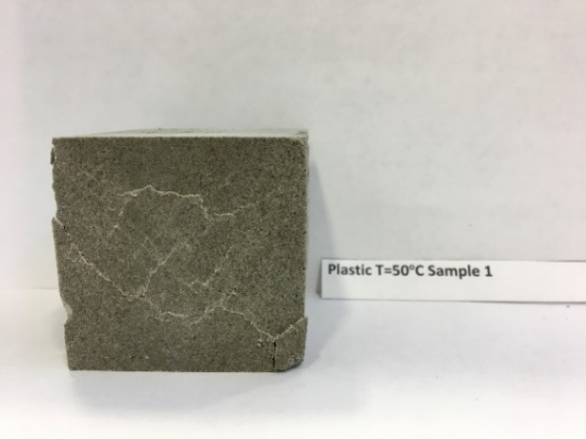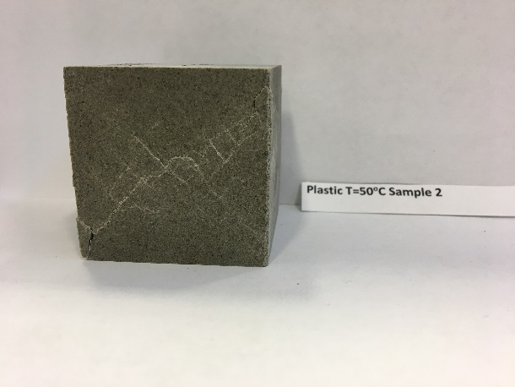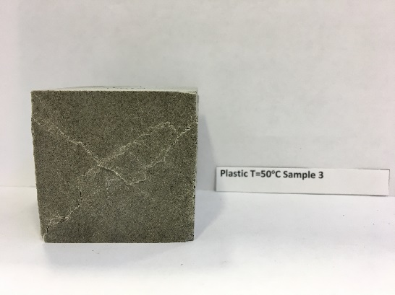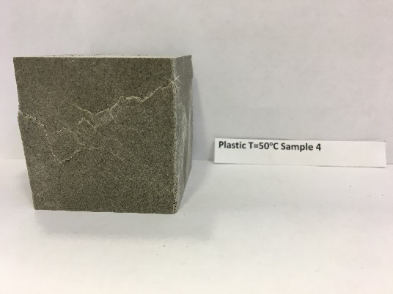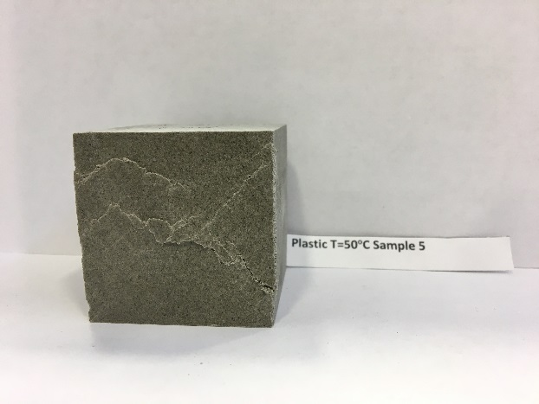

Plastic Samples Wet at Room Temperature

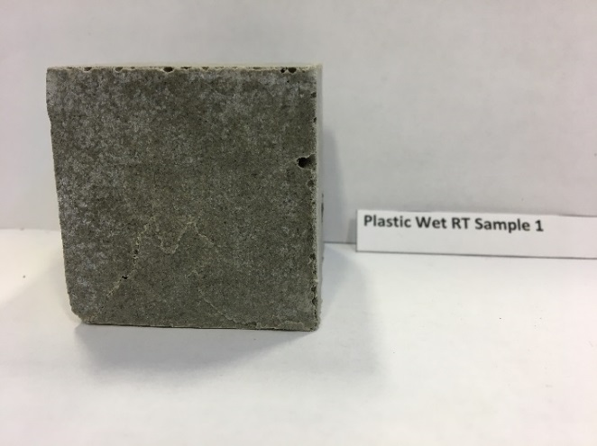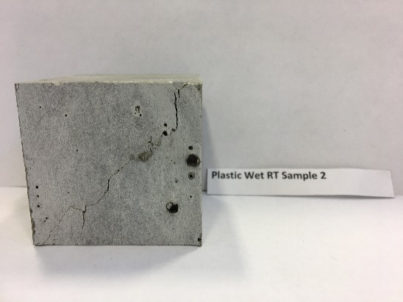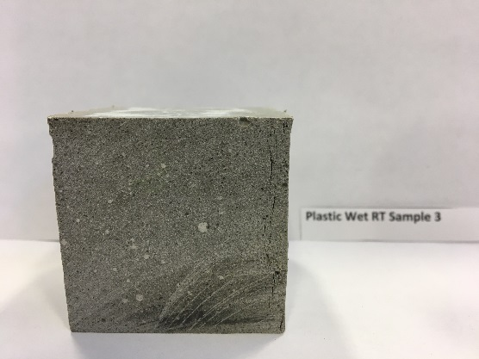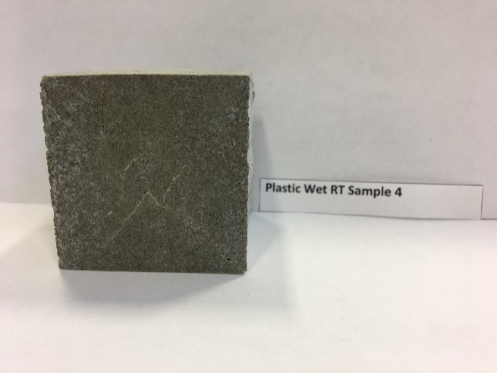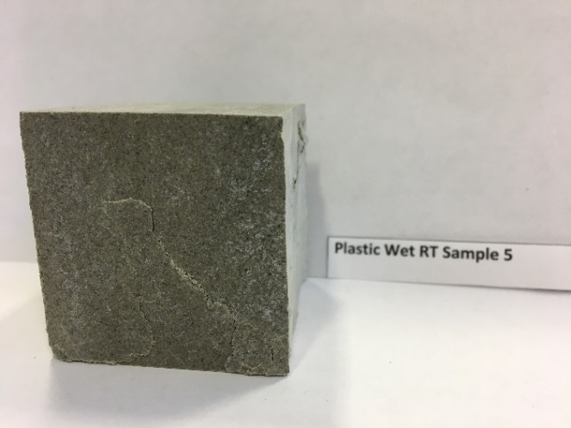

Appendix 2: Flexural Testing

Concrete Samples at Room Temperature

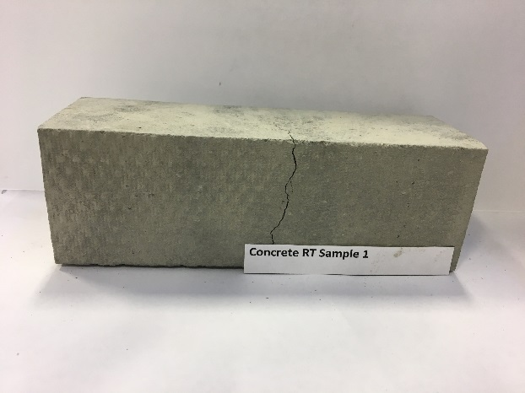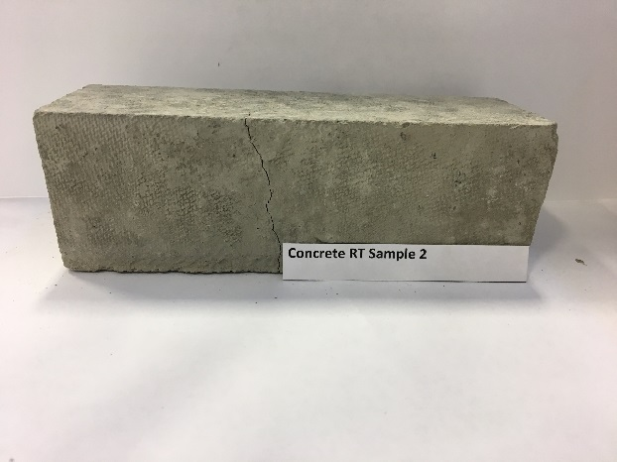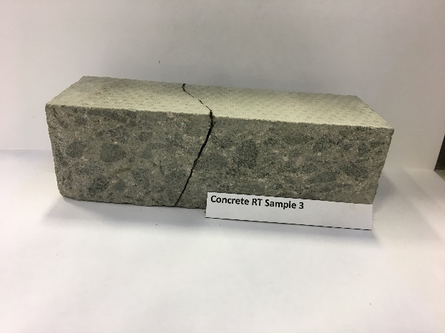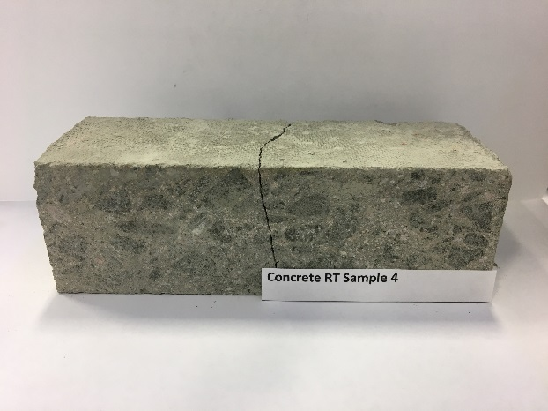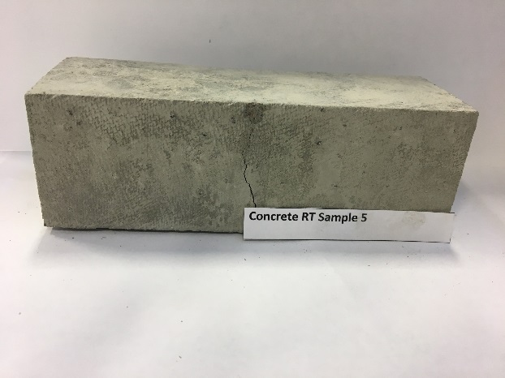

Concrete Samples at -20ºC

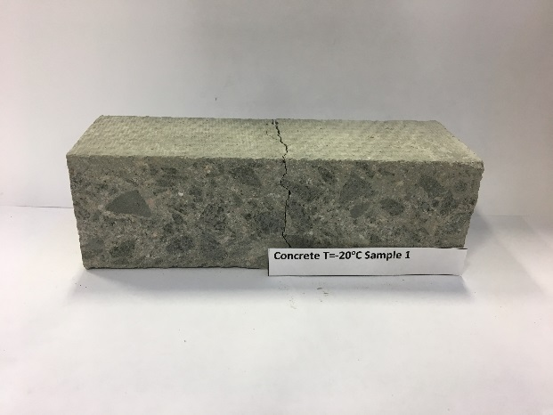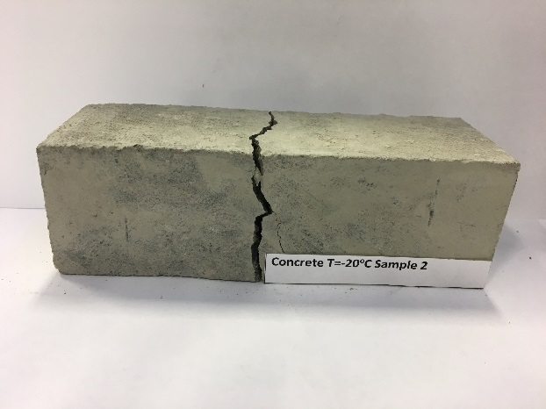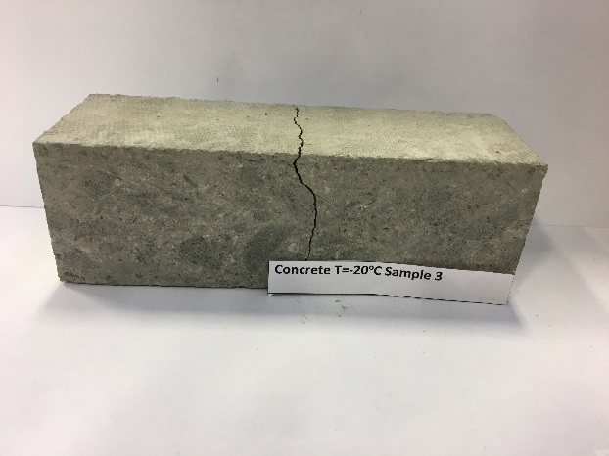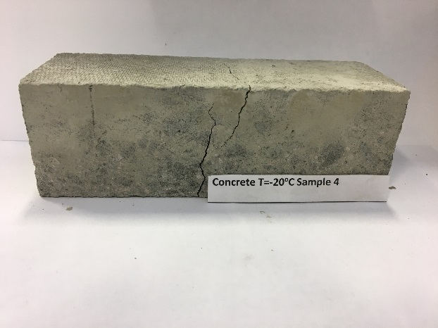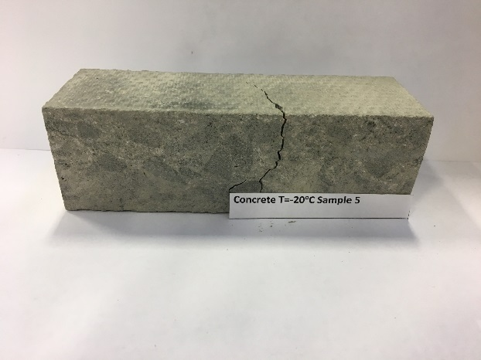

Concrete Samples at 50ºC

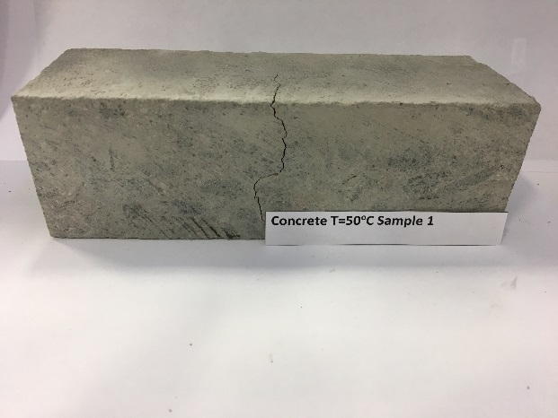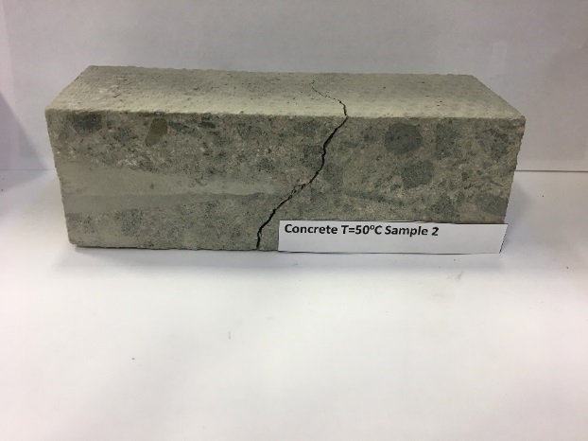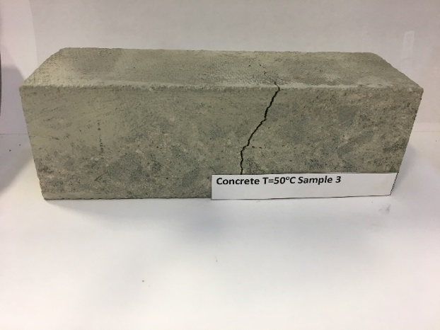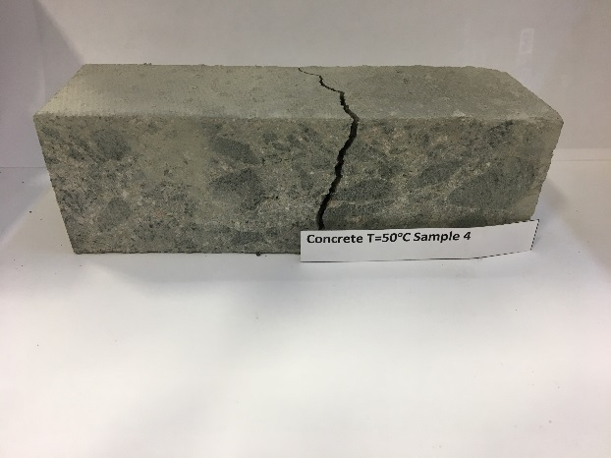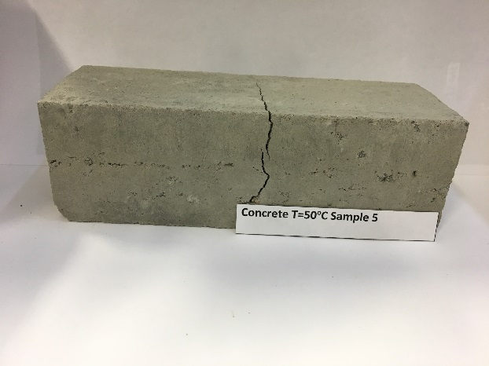

Concrete Samples Wet at Room Temperature

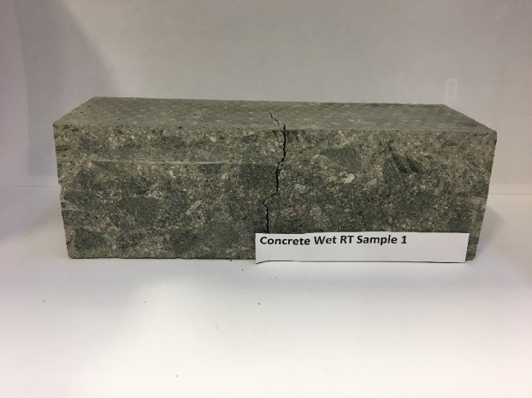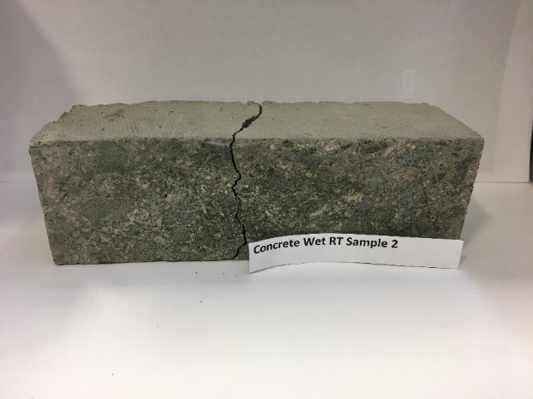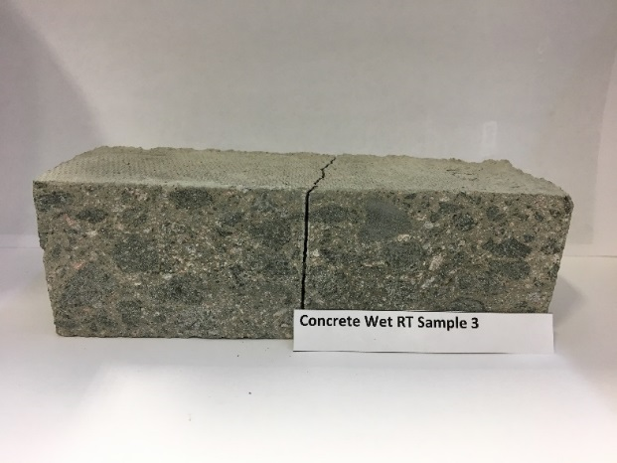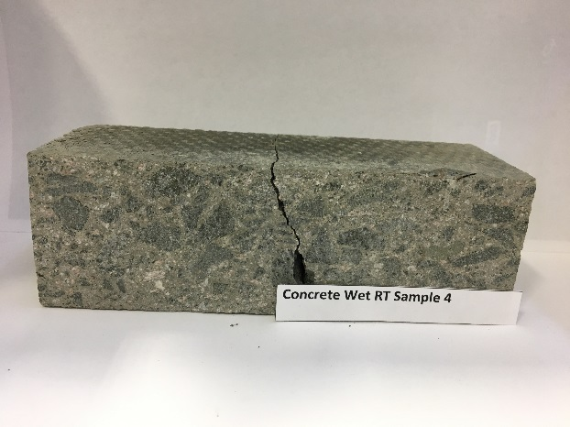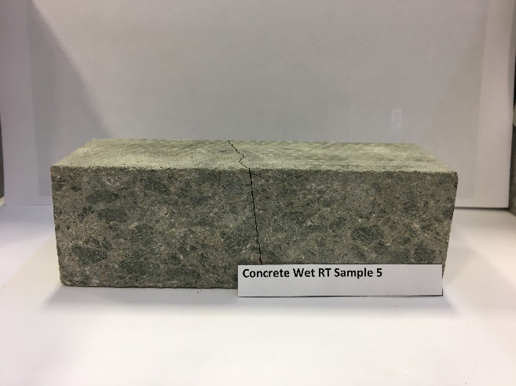

Plastic Samples at Room Temperature

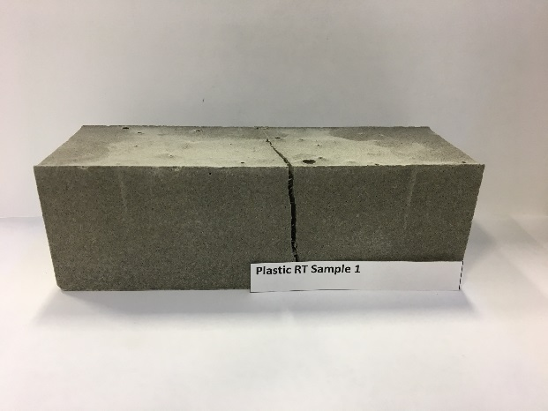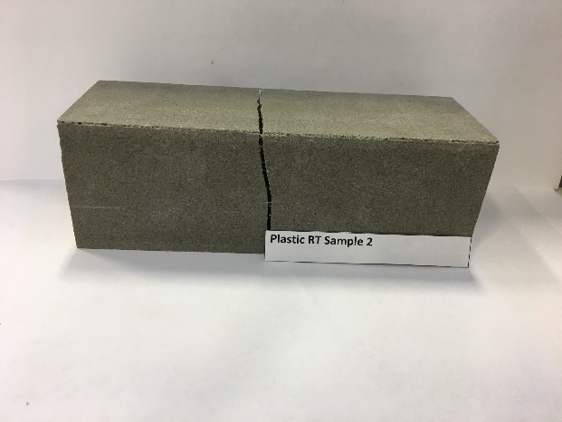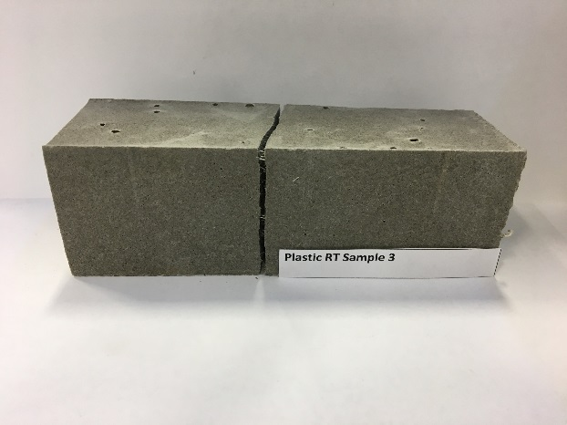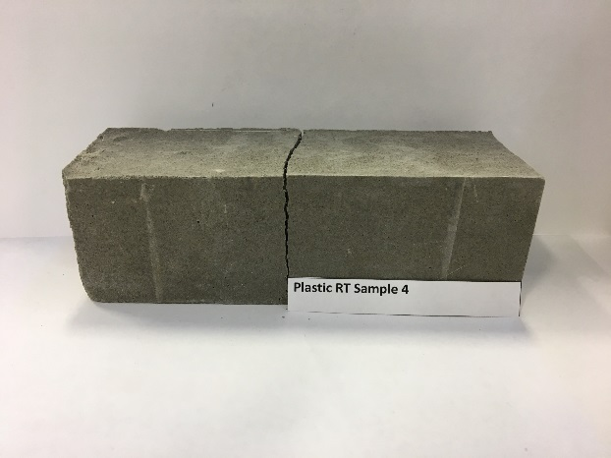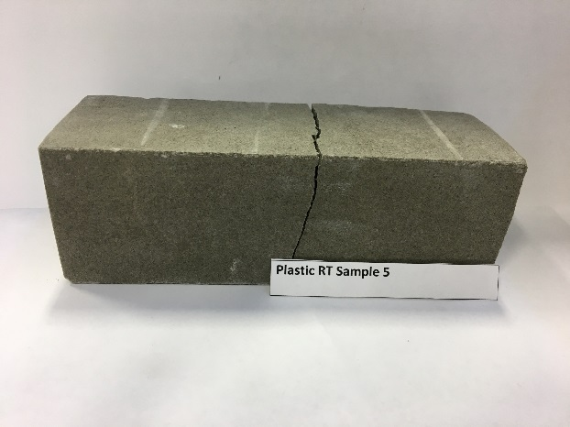

Plastic Samples at -20ºC

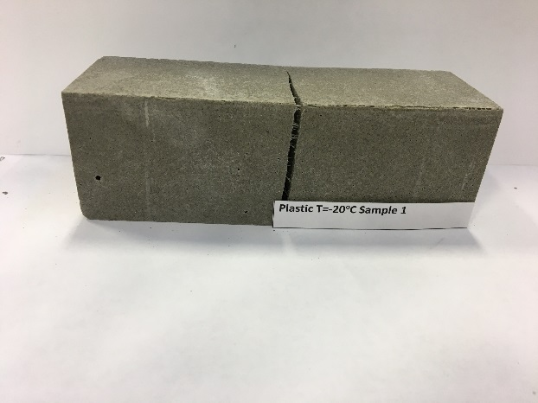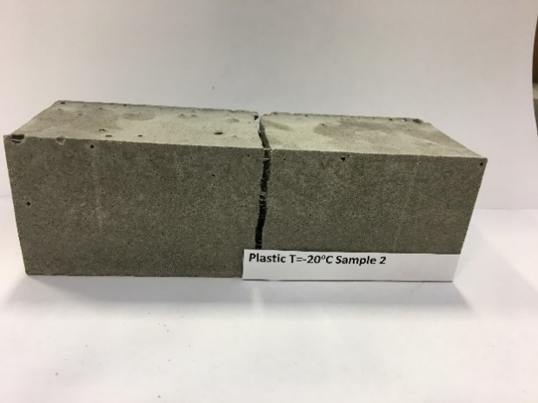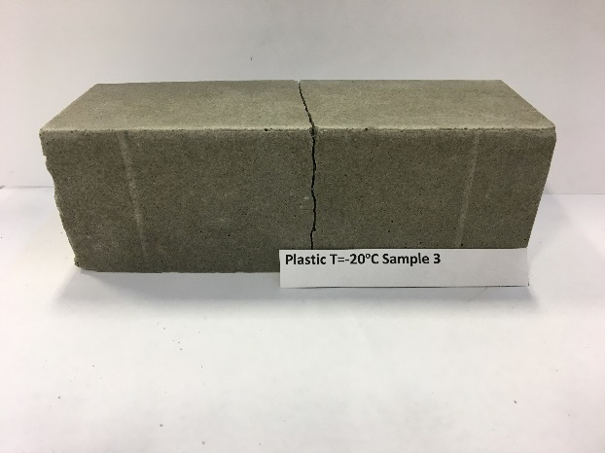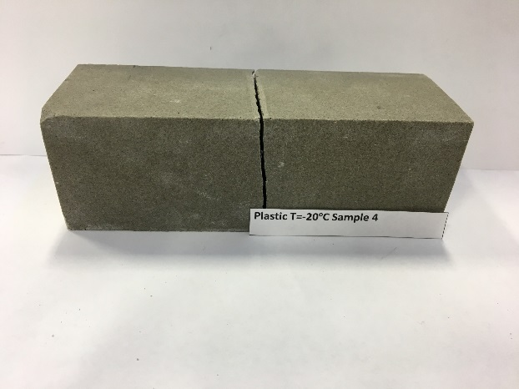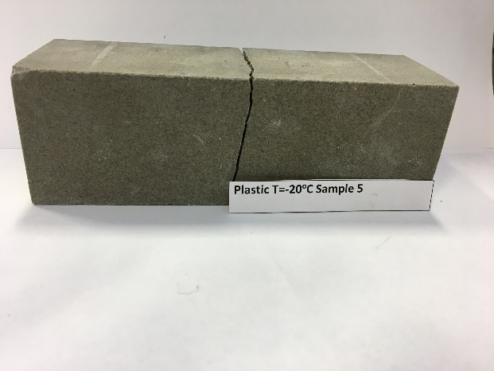

Plastic Samples at 50ºC

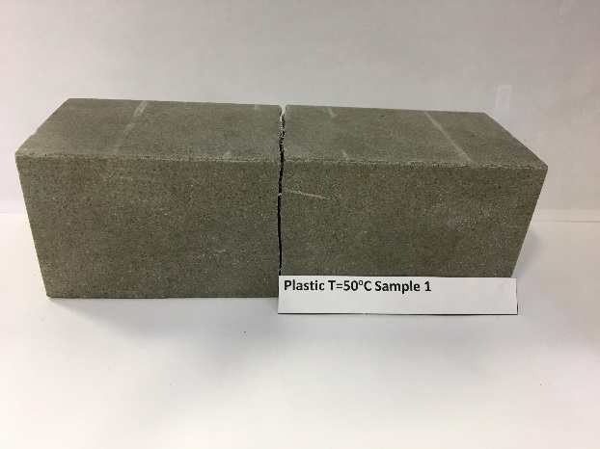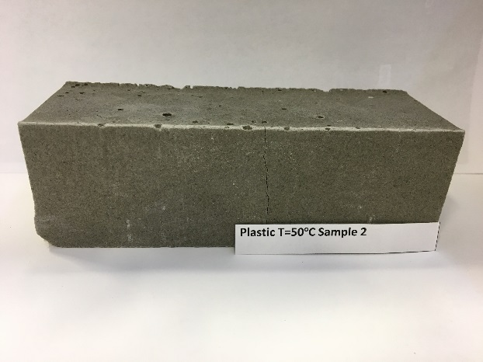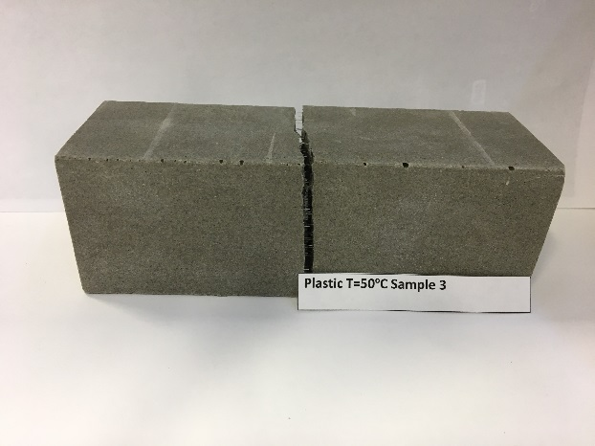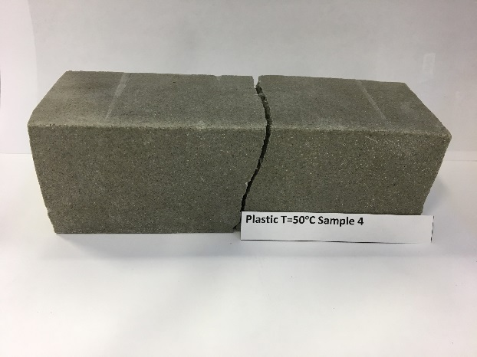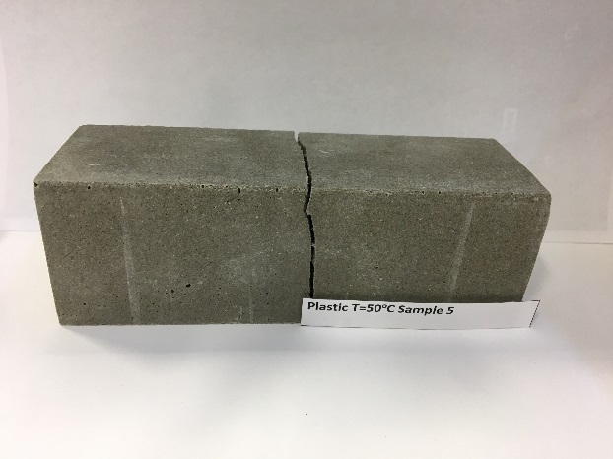

Plastic Samples Wet at Room Temperature

